Git & Github

Download and install git:
Download from : git-scm.com
Gitbash is a terminal based on Unix OS.
General Concept :
* Working area --> Staging area --> Respository
* Push --> Act of sending file to github remote server from local PC
* Pull --> Act of receiveing changes from remote to local PC
* Remote --> Duplicate instance of repository on remote server
* Clone --> Act of downloading the repository to local PC

Create github Account:
- Open github.com
- Create account
- Create New repository by clicking + icon with any valid repository name

Open git from terminal:
- Command to check git version : git version

Git configuration username and email:
- git config --global user.name "raju-shrestha"
- git config --global user.email “rajushrestha2007@gmail.com”

Check the username and email verification:
- git config --global –list
This command will display username and email which is configured.

Directory/location:
- Check the Current directory : pwd
- Change directory : cd directoryname
- Change the directory to 1 step back: cd ..

Create Directory/Folder:
- Create directory on PC (Let it be on Desktop).
- Command to create directory : mkdir directoryname (eg. Github)
- Put files in that directory which we are going to push.
- Change directory : cd directoryname

Initialize git and check status:
- git init
- git status
This command will show you a list of all untracked files and directories in your repository.
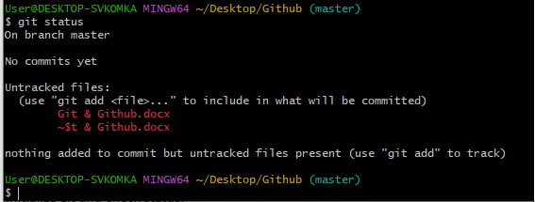
Untracked files in Git are files present in your working directory that are not currently under Git's version control. This means Git does not know about their existence, and they are not part of any commit history.

Adding Untracked Files to Git:
- git add <filename>
To add all untracked files in the current directory
- git add . OR git add -A
This moves the specified files from the untracked state to the staged state, preparing them for the next commit.

Check the status of file after git add command: git status
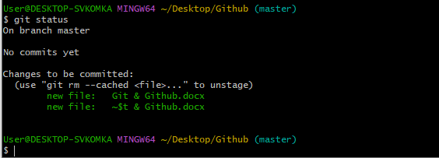

Git commit: git commit -m "Commit Message"
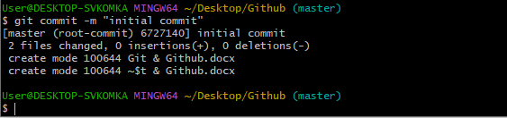

Check git status of current working direcory: git status
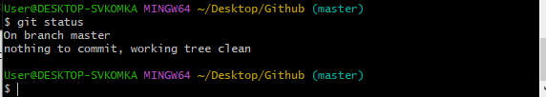
Check committed files in history: git log
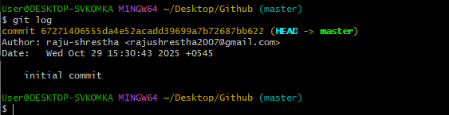

To clear git command from terminal: clear

Remove Unnecessary file:
- git rm ‘filename”
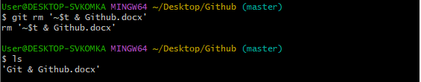

To make separate branch:
- git branch branchname
Delete Branch:
- git branch -d branchname

List all the branch in the current repository: git branch
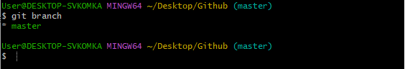

Switching/Change between the branch: git checkout branchname
Merge two branch:
- First go to master branch: git checkout master
- Then git merge branchname which you want to merge.

Create New repository in git server after creating github account
- Click on + icon to create new repository.
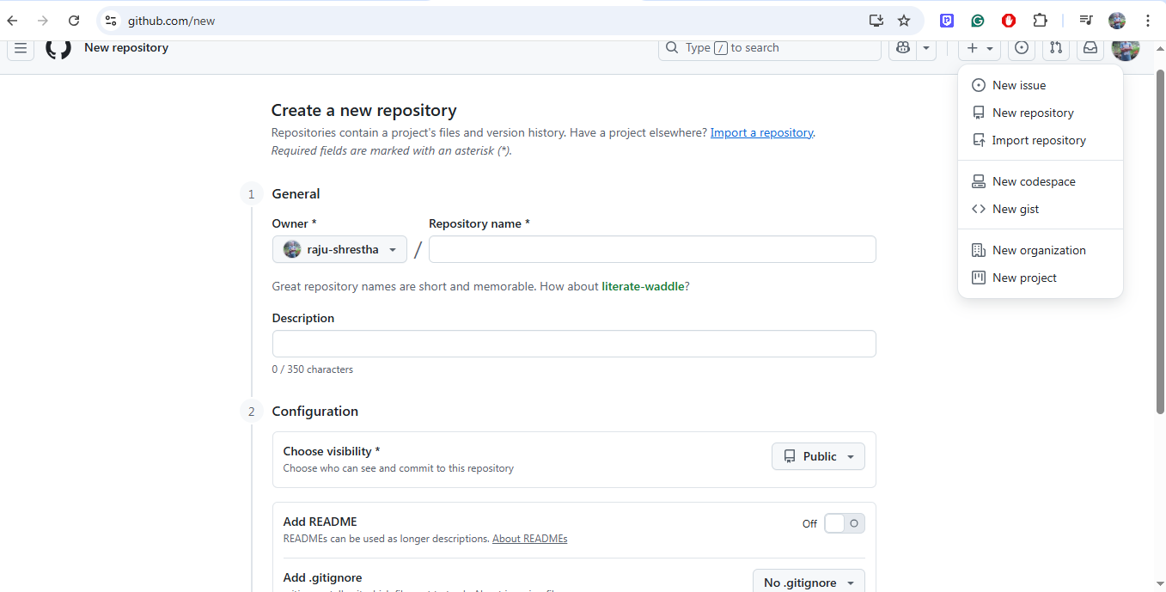

Connect local git repository to remote repository:
- git remote add origin https://github.com/raju-shrestha/Git-Github.git
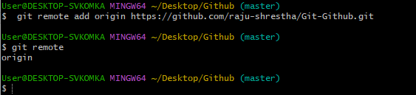

Git push origin to master branch: git push -u origin master
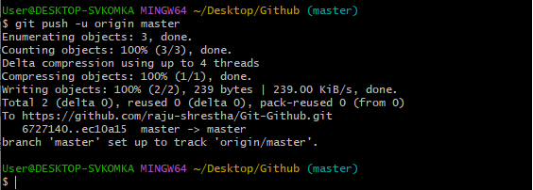

Now clone the pushed repository
Git Clone:
- Copy/download the repository from github to your local PC called git clone.
- Change the directory where you want to clone the repository: cd directoryname
- git clone https://github.com/raju-shrestha/Git-Github.git

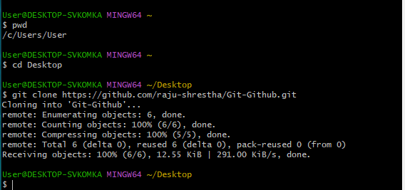

Make some changes in this file and check the status: git status
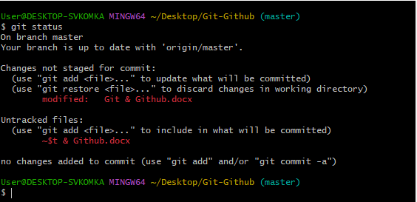

The modified file is not commited so first add it to stagging area.
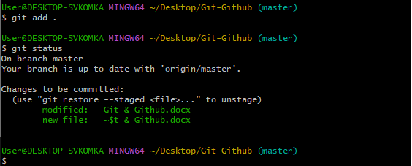
Commit the changes: git commit -m “Commit Message”

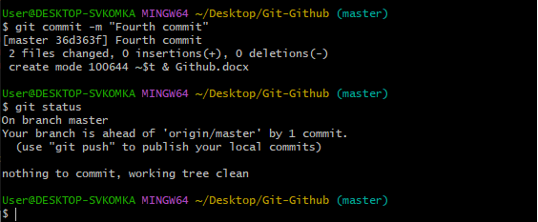

Push the committed file: git push -u origin master
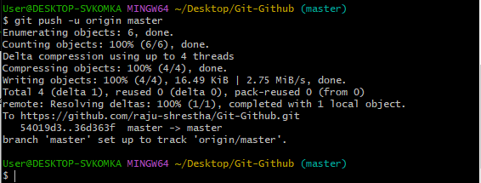

Finally, the changed file is push to github remote repository.

Git Pull:
The git pull command in Git is used to fetch and download content from a remote repository and immediately update the local repository to match that content.
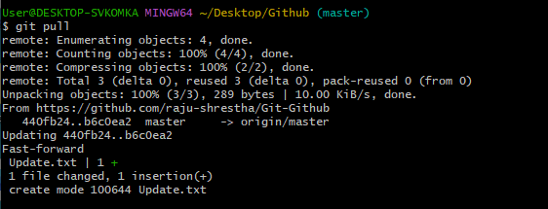

Add Collaborator:
A Git collaborator is an individual granted access to contribute to a Git repository, typically hosted on platforms like GitHub. This access allows them to make changes, push code, and actively participate in the development of a project.

For adding collaborator: Go to settings
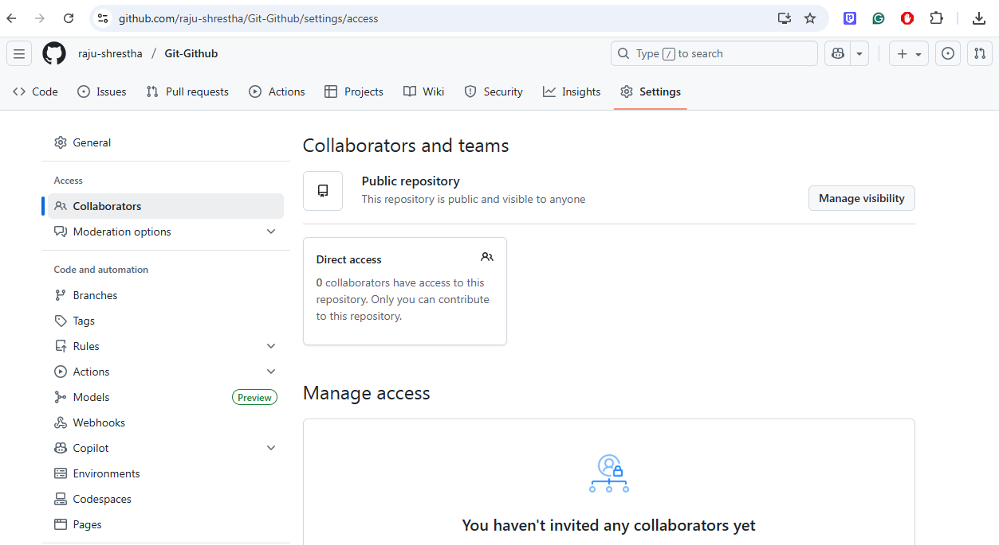
Go to collaborators then add people.
And give correct username or email address of collaborators who you want to make.

Accept the request from collaborator site.
Then clone the repository to your local PC.
Make some changes to file and then add, commit and push to remote repository.
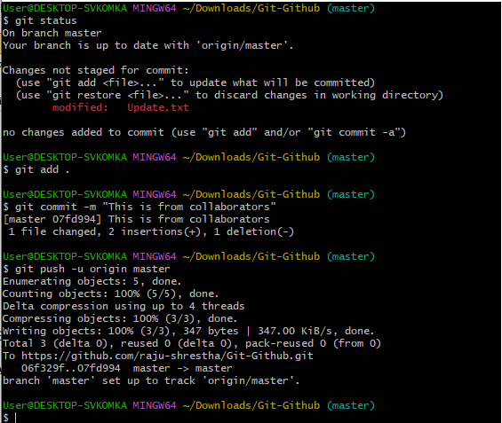
Now pull the changes made by collaborators.
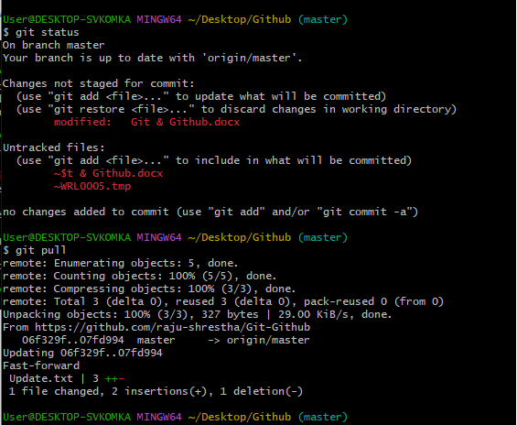

Finally, last update is pulled and the repository is upto date.

